American International University-Bangladesh (AIUB)  
**Department of Computer Science  
Faculty of Science & Technology (FST)**

**Home Service**

A Software Quality and Testing Project Submitted

By

|  |  |  |  |  |
| --- | --- | --- | --- | --- |
| **Semester: Fall_23_24** | | | **Section:** | **Group No:** |
| **SN** | **Student Name** | **Student ID** | Individual  Contribution (in %) | Total Marks: 50 |
| Earned Marks: |
| 02 | TANZIM AHMOD | 18-37896-2 | 25 |  |
| 06 | RAGIB ANIS RIFAT | 19-41016-2 | 25 |  |
| 07 | TAREKUZZAMAN MOIN | 19-41025-2 | 25 |  |
| 24 | MD. IMRAN HOSSEN | 20-43564-1 | 25 |  |

The project will be Evaluated for the following Course Outcomes

|  |  |  |
| --- | --- | --- |
| **EVALUATION CRITERIA** | **Total Marks (50)** | |
|  | |
| Revision History, Test Plan Identifier, Reference Materials, Problem Background, Solutions | [10 Marks] |  |
| Requirements Specification (System feature, Quality Attributes, System Interface, Project Requirements) | [10 Marks] |  |
| Item Not to be tested, Testing approach (Testing levels, tools, meetings), Test cases | [10 Marks] |  |
| Item pass/fail criteria, Test deliverables, Staffing and Training, Responsibilities, Scheduling, Risk | [10 Marks] |  |
| Approval, Format, Submission, and Defense | [10 Marks] |  |

Software Test Plan

For

<Home Service>

Version 1.0 approved

Prepared by <

TANZIM AHMOD

RAGIB ANIS RIFAT

TAREKUZZAMAN MOIN

MD. IMRAN HOSSEN>

< American International University Bangladesh >

<27th November 2023>

Table of Contents

Revision History 3

1. TEST PLAN IDENTIFIER: AT-TP01.3 4

2. REFERENCE MATERIALS 4

3. INTRODUCTION 4

3.1 Background to the Problem 4

3.2 Solution to the Problem 4

4. REQUEIREMNT SPECIFICATION 4

4.1 System Features 4

4.2 System Quality Attributes 5

4.3 System Interface 5

4.4 Project Requirements 5

5. FEATURES NOT TO BE TESTED 5

6. TESTING APPROACH 5

6.1 Testing Levels 5

6.2 Test Tools 5

6.3 Meetings 5

7. TEST CASES/TEST ITEMS 6

8. ITEM PASS/FAIL CRITERIA 6

9. TEST DELIVERABLES 6

10. STAFFING AND TRAINING NEEDS 6

11. RESPONSIBILITIES 6

12. TESTING SCHEDULE 7

13. PLANNING RISKS AND CONTINGENCIES 7

14. APROVALS 7

# Revision History

|  |  |  |  |
| --- | --- | --- | --- |
| **Revision** | **Date** | **Updated by** | **Update Comments** |
| 0.1 | 2023.09.16 | TANZIM AHMOD | Initial Draft |
| 0.2 | 2023.10.24 | RAGIB ANIS RIFAT | Added details to testing approach and deliverables |
| 0.3 | 2023.11.15 | TAREKUZZAMAN MOIN | Revised test cases and pass/fail criteria |
| 0.4 | 2023.12.20 | MD. IMRAN HOSSEN | Finalized test plan, added approvals |
|  |  |  |  |
|  |  |  |  |

# TEST PLAN IDENTIFIER: TP-HS01.3

# REFERENCE MATERIALS

* October, Z.H. and Husna, Z. (2023) *Bangladesh Maid Agency: Clients allege fraud and unreliable service*, *The Business Standard*. Available at: https://www.tbsnews.net/features/panorama/bangladesh-maid-agency-clients-allege-fraud-and-unreliable-service-714790 (Accessed: 24 December 2023).
* Rahman, F. (2023) *Laundry problems for bachelors and single people living in Dhaka City: How laundry wala can help*, *LinkedIn*. Available at: https://www.linkedin.com/pulse/laundry-problems-bachelors-single-people-living-dhaka-fahim-rahman (Accessed: 24 December 2023).
* *An online system for household services | semantic scholar*. Available at: <https://www.semanticscholar.org/paper/An-Online-System-for-Household-Services-Indravasan-Adarsh/d4d5a5798ef365efbe1ccf9ae0948645ea7f2839>.
* *An online system for home services - IJSDR*. Available at: <https://www.ijsdr.org/papers/IJSDR2009067.pdf>

# INTRODUCTION

## 3.1 Background to the Problem

In today’s busy world, many people are caught up in their work so much that they often forget about spending time with their families. Sometimes, unexpected problems come up, and we end up focusing more on work than on other important things in life. Imagine having a house where everything works perfectly—no leaky pipes, no hassle in fixing furniture, and no need for constant repairs. Wouldn't it be great if getting services for your home was easy and didn't involve a lot of negotiation or confusion?

This is where E-Commerce, or online services, becomes important. It makes our lives easier by providing many benefits. So, thinking about these challenges, we want to create a system that brings various services to your doorstep with just one click. These services could include plumbing, moving, repairs, cleaning, electrical work, painting, taxi services, laundry, and more. To make it even easier for you, our system can be accessed through your mobile phone.

Booking a service is a simple process, and once you've chosen a service, our system will send you an email to confirm your selection. You can even upload pictures to show exactly what you need. The best part is that you can book services from anywhere to anywhere you want. This new system aims to make your life more comfortable by making essential services just a click away.

**Background Description:**

The Home Service System project aims to address a prevalent issue in today's fast-paced society where individuals often find it challenging to balance work commitments with personal responsibilities, particularly spending quality time with their families. The project recognizes that unforeseen problems in the household, such as maintenance issues or the need for various services, can compound this challenge. The vision is to create a streamlined and efficient solution that simplifies the process of accessing essential home services.

In today’s busy world, many people are caught up in their work so much that they often forget about spending time with their families. Sometimes, unexpected problems come up, and we end up focusing more on work than on other important things in life. Imagine having a house where everything works perfectly—no leaky pipes, no hassle in fixing furniture, and no need for constant repairs. Wouldn't it be great if getting services for your home was easy and didn't involve a lot of negotiation or confusion?

**Root Cause of the Problem:**

The root cause of the problem lies in the busy lifestyles that individuals lead, resulting in a tendency to prioritize work over essential aspects of personal life, including home maintenance and family time. This problem is of paramount importance due to the potential negative impact on the quality of life, family relationships, and overall well-being. Neglecting home-relat ed issues can lead to increased stress, decreased comfort, and the potential for more significant problems over time.

The significance of this problem is underscored by the need for a solution that not only addresses the immediate service requirements but also aligns with the modern digital era. With the increasing reliance on technology, there is an opportunity to leverage e-commerce and online services to create a platform that makes essential home services more accessible, convenient, and hassle-free.

By providing a platform where users can effortlessly book a variety of services ranging from plumbing and repairs to transportation and cleaning, the Home Service System aims to mitigate the challenges associated with managing a household. The ability to access these services through a mobile phone adds an extra layer of convenience, allowing users to seamlessly integrate essential tasks into their busy schedules.

In summary, the Home Service System project is motivated by the recognition of the time constraints and challenges individuals face in maintaining a balanced life. By addressing the root cause of this problem and leveraging technology, the project seeks to make essential home services readily available, ultimately enhancing the overall quality of life for users.

## 3.2 Solution to the Problem

The proposed solution to address the challenges outlined in the case is the development of an online system for home services. Basically the idea to solve the problem is to create a website or app where people can easily get help with home tasks. In today's busy life, it's hard for many to find time for family and home chores. So, we want to make it simple—just one click, and you can book services like plumbing, moving, repairs, cleaning, and more. Here are the solutions we propose:

**Convenience and Accessibility**: Users of the online system can conveniently and hassle-free access a range of home services with just one click. The system is mobile-friendly, allowing users to conveniently access services while on the go.

**Service Search Capability:** In our system, users can effortlessly search for the specific services they need. This feature allows them to quickly find and access a wide range of services, from plumbing to cleaning, by entering relevant keywords or phrases.

**Service Variety:** In addition to plumbers, movers and packers, repairmen, cleaners, electricians, painters, cab services, laundry, and more, the system provides a wide range of services.

**Simple Booking Process:** The procedure of reserving services is intended to be simple so that users may choose the services they require with ease.

**Show What You Need:** You can even upload pictures to show exactly what you want help with. This makes sure the person coming to help knows what you need.

**Confirmation and Authentication:** The system sends a confirmation email to users after they have booked a service, providing assurance and confirming their selection. Authentication is implemented for users, including service seekers, service providers, and administrators, ensuring that the system is secure and only accessible to authorized individuals.

**Fixed Prices:** We have fixed prices for services, so you don't have to bargain. This helps make things clear and fair for everyone.

**Secure Online Payment Gateway:** The platform incorporates a secure online payment gateway, allowing users to make payments for services in a safe and convenient manner. This feature eliminates the need for cash transactions, adding an extra layer of security.

**Rating the Services:** Users can give a score to the services. It's like saying how good or not good the help was. It helps others know if the service is good or not. User just click on some stars to show their rating. Simple and quick!

**Feasibility of the Solution:**

Since the suggested approach makes use of current technology and fits in with the growing trend of online service platforms, it is workable. Negotiations become less complicated thanks to the fixed price strategy, which benefits users. A secure payment gateway is included to guarantee the safety of the financial transactions. The fact that smartphones are widely used and the environment is mobile increases the viability even more. Overall, the solution is in a good position to achieve the company's goals of offering hassle-free and effective home services.

**Short Description of the Software:**

The software we're talking about is a handy tool designed to help people with their household tasks. Its main goal is to make it super easy for users to get services like plumbing, cleaning, and more. The benefits include saving time, avoiding hassles, and ensuring reliable help at the click of a button. The objectives are to simplify the process of accessing various home services, provide a user-friendly interface, and enhance overall convenience. The software aims to streamline home maintenance, making life easier for users.

**Existing Studies in the Problem Area:**

In the realm of domestic services, several existing software solutions aim to address common challenges. Our software stands out as an extensive, all-in-one solution, emphasizing accuracy and efficiency in product design. Some competitors operating in the national and international markets include Sheba.xyz, Zantrik, Mistry Tech Ltd., Standard Colors, Home Center, PLATI, Right Time, and others.

While these competitors offer a range of services, our software aims to provide customers with versatile, general-purpose embedded solutions for daily activities. We cover major home and office services, with a focus on capturing the domestic market. Notably, our main competitors are currently local service providers, ensuring a targeted approach.

In the industry, service providers operate on specific terms. For instance, Zantrik specializes in automobile maintenance, Mistry Tech Ltd. in modern interior design, and Sheba.xyz connects households and businesses with various services. However, there are certain services not readily available on their platforms, such as cleaning services, business lunches, drone services, etc.

Our unique offerings include subscription-based services like corporate lunches, maid services, automobile services, and house cleaning. We believe our platform is distinct in the domestic marketplace, not only locally but globally. With a focus on providing a comprehensive and unparalleled solution, we aim to redefine the landscape of domestic service platforms.

# REQUEIREMNT SPECIFICATION

## 4.1 System Features

**1. System Registration**   
**Functional Requirements**

* 1. The user must specify their user type (service provider or customer/service receiver) before accessing the registration page.
  2. The software should enable users to register with their information and receive a manual username and password for login.
  3. Upon successful registration, the user gains access to enter the application based on their user type.

Priority Level: High  
Precondition: The user must have valid email address

**2. User Account**  
**Functional Requirements**

* 1. Users with the user type "service receiver" can avail services from service providers.
  2. After registering the user can log in as a service receiver.
  3. After logging in, users can update personal details such as name, address and age.
  4. Users have the option to set a phone number to verify their accounts.
  5. The system verifies the correctness of the provided phone number and sends a message for verifying the account.
  6. After successfully verification to the system, user can access to the services.

Priority Level: High  
Precondition: The user must have valid username and password

Cross reference: 1

**3. Service Provider Account**  
**Functional Requirements**

* 1. After registering the service operator can log in as a “service receiver”.
  2. After logging in, service provider can also update personal details such as name, address and age.
  3. Service Provider has the option to set a phone number to verify their accounts for giving services to the users.
  4. Service provider also has to select which type of services he provides.
  5. The system verifies the correctness of the provided phone number and sends a message for verifying the account.

Priority Level: High  
Precondition: The service provider must have valid username and password

Cross reference: 1

**4. Search Home Services**  
**Fun ctional Requirements**

* 1. The system automatically provides users with nearby service providers for home services and he can search services with his preferred keyword.
  2. Users can choose from various types of home services available.

Priority Level: High  
Precondition: The user must be verified

Cross reference: 2

**5. Booking Home Services**  
**Functional Requirements**

* 1. Users can select their preferred time and service provider for home services
  2. If a specific service provider is not selected, the system automatically assigns one from the chosen category.
  3. The system sends a confirmation message to both the customer and the service provider.

Priority Level: High  
Precondition: The user must be verified

Cross reference: 2

**6. Service Provider Schedule**  
**Functional Requirements**

* 1. Service providers can set their availability schedule.
  2. The system automatically updates the service provider's schedule based on selected time slots.
  3. Service providers can offer discounts or special promotions.
  4. The system notifies users about the available offers.

Priority Level: High  
Precondition: The service providers must be verified

Cross reference: 3

**7. Cancel Service Request**  
**Functional Requirements**

* 1. Users can cancel their booked home service at any time, and the system will update the service provider's schedule accordingly.
  2. If a customer fails to show up without canceling the booking, the system automatically cancels the appointment and marks the user with a red flag.

Priority Level: High  
Precondition: The user must have a booked home service

Cross reference: 5, 6

## 4.2 System Quality Attributes

**QA1 - Integrity:** The login process includes two-step verification: the system sends a verification code via email, and users must use their password for login.

Priority Level: High

Precondition: N/A

**QA 2. Efficiency:** The system is optimized to use 400 MB of RAM (10% of a 4GB RAM module) and 20% of a 2 CORE CPU under full load, ensuring efficient resource utilization.

Priority Level: High

Precondition: N/A

**QA 3. Availability:** The system shall maintain a minimum availability of 98 percent every day from 8:00 am to 9:00 pm local time.

Priority Level: High

Precondition: Must have the maintainability attribute.

**QA 4. Flexibility:** A maintenance programmer should be able to add new features and functions, including code modifications and testing, within four hours.

Priority Level: Medium

Precondition: N/A

**QA 6. Maintainability:** In the event of a system issue, such as a user being unable to book a service, a maintenance programmer with experience should resolve the problem within 2 hours without additional assistance.

Priority Level: High

Precondition: N/A

**QA 7. Portability:** The system is designed to run on any platform or operating system, including Windows, Android, and Apple.

Priority Level: High

Precondition: N/A

**QA 8. - Usability:** The system ensures a user-friendly interface, allowing users to easily navigate and access services. Clear instructions and intuitive design contribute to a positive user experience.

Priority Level: High

Precondition: N/A

## 4.3 System Interface

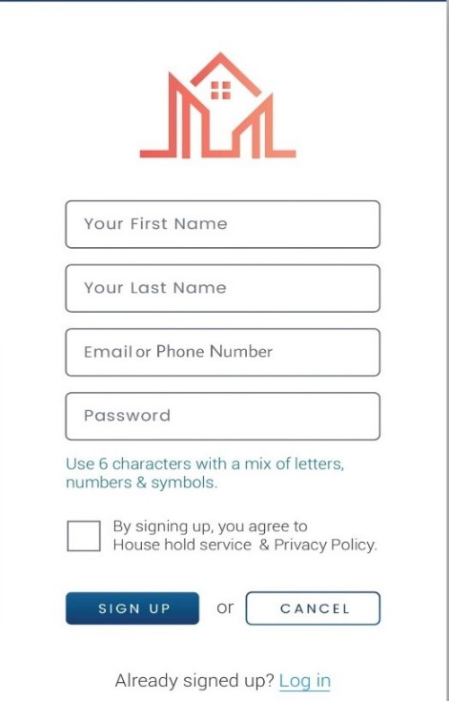 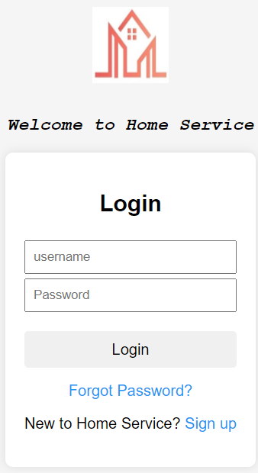

Screen 1: Registration

Screen 2: Login

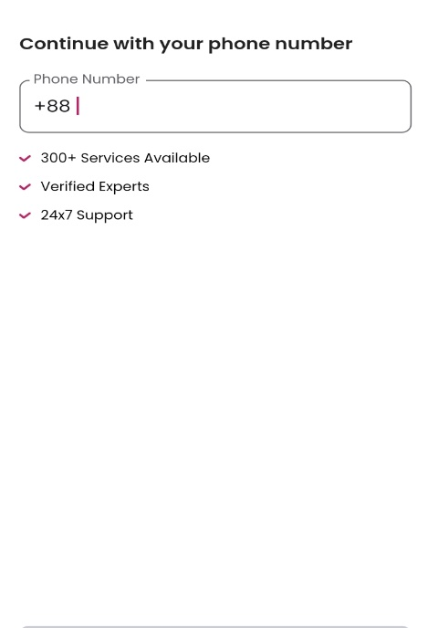 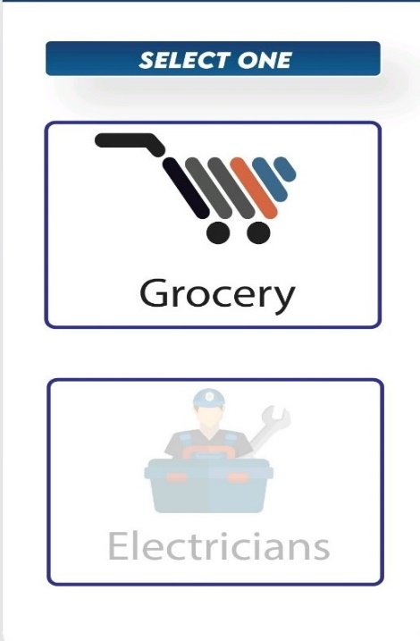

Screen 4: Service Type

Screen 3: Number Verification

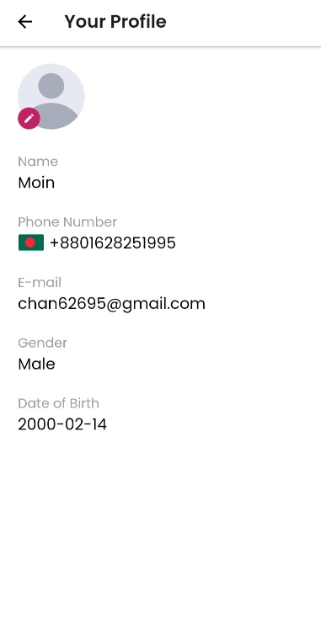 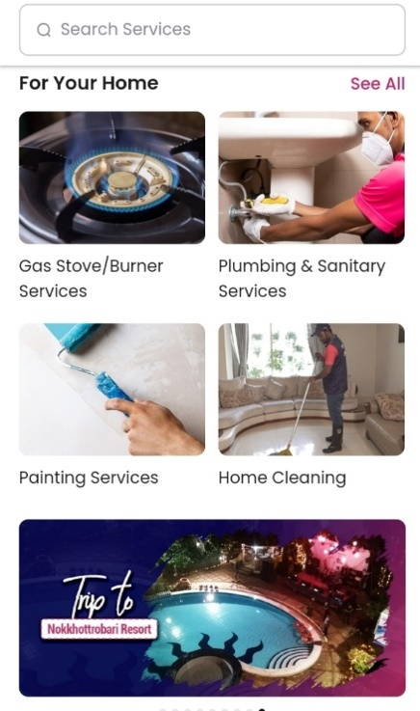

Screen 6: Services

Screen 5: Profile



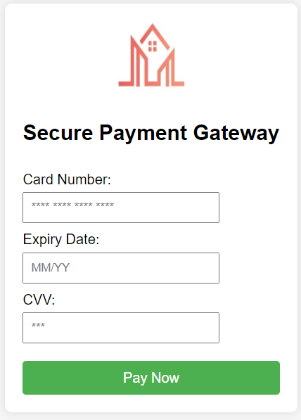

Screen 7: Service Rating

Screen 8: Payment

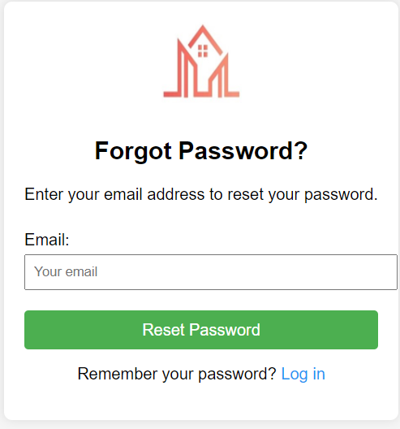

Screen 9: Reset Pass

## 4.4 Project Requirements

1. **Time**: Project completion within 6 months (26 weeks).
2. **Budget:** No specific budget constraints defined.
3. **Resources**: Project team consists of 4 members.
4. **Environment**: Team working remotely from home.
5. **Equipment**: Each team member requires a device (laptop), integrated development environment (IDE), and necessary frameworks for system development.
6. **Bandwidth**: High bandwidth support of 30 to 50 Mbps is needed for efficient remote collaboration.
7. **Tools**: System developers require Selenium tools for testing activities.

# 5. FEATURES NOT TO BE TESTED

Here are some features that might not typically be tested in a home service project or similar contexts:

* **Non-Critical UI Elements:** Minor cosmetic aspects of the user interface that do not impact functionality may not be a priority for testing.
* **Unsupported Browsers or Devices:** If the project specifies a limited set of supported browsers or devices, testing on unsupported ones might be excluded.
* **Extreme Load Conditions:** In some cases, extreme load conditions (beyond the anticipated usage) is not tested if they are unlikely to occur in real-world scenarios.
* **User Documentation Edits:** Minor edits to user documentation that do not impact critical information or instructions are not rigorously tested.
* **Low-Priority Performance Optimization:** Performance optimizations that are considered low-priority and do not significantly impact user experience under normal conditions are not thoroughly tested.
* **Non-Functional Requirements with Low Impact:** Non-functional requirements, such as response time for non-critical operations, are given less testing focus if they have a low impact on overall user satisfaction.
* **Obsolete Features:** Features that are marked for deprecation or removal in future versions are not thoroughly tested, especially if they are not critical to the current version.
* **Redundant Error Conditions:** Testing every possible error condition, especially those that are redundant or unlikely to occur, may not be a high priority.

# 6. TESTING APPROACH

## Testing Levels

**Unit Testing:**

In the testing process for the home Service Application, Unit Testing plays a crucial role in assessing individual units of code, such as functions, classes, and modules, in isolation. Employing tools like Jest, JUnit, PHPUnit, and Mockito, this level of testing ensures that each component functions as intended and conforms to specified requirements. The established criterion for success in Unit Testing is achieving code coverage of over 80%, indicating a thorough examination of the codebase. This level of testing is integral to identifying and rectifying issues at an early stage in the development process, contributing to the overall reliability and stability of the application.

**Integration Testing:**   
Integration Testing is a vital phase in the testing strategy for the home Service Application, where the focus is on evaluating how different units of code interact with each other. This level of testing ensures the seamless integration of various components to verify that they work cohesively as part of the larger system. Utilizing tools such as SoapUI, RestAssured, and Selenium WebDriver, Integration Testing examines the interoperability of services, APIs, and critical user flows. The testing coverage extends to all API endpoints and essential user pathways, ensuring that data exchange and communication between different modules are robust and error-free. By conducting thorough Integration Testing, potential issues arising from the integration of individual components are identified and addressed, contributing to the overall stability and functionality of the application.

**System Testing:**   
System Testing is a pivotal stage in the testing process for the home Service Application, aiming to assess the entire application comprehensively against system requirements. This level of testing is designed to evaluate the collective functionality of the application as a cohesive whole. Leveraging tools such as Selenium WebDriver for web applications, Appium for mobile platforms, and Cypress.io for end-to-end testing, System Testing covers a wide spectrum of criteria. The testing coverage spans all functionalities of the application, ensuring that every feature operates as intended. Additionally, System Testing evaluates performance metrics to guarantee optimal responsiveness and identifies and addresses potential security vulnerabilities. By conducting robust System Testing, the application's overall reliability, performance, and security are thoroughly scrutinized, contributing to a robust and dependable end product.

**Acceptance** **Testing:**   
Acceptance Testing is a pivotal phase in the testing strategy for the home Service Application, focusing on evaluating the application from the end user's perspective to ensure alignment with specified requirements. In this testing level, the emphasis is placed on verifying that the application meets user expectations and delivers a positive experience. Leveraging tools such as manual testing methodologies and user testing platforms like UserTesting and Lookback, Acceptance Testing provides insights into how end users interact with the application. The testing coverage includes core functionalities, thoroughly assessing that key features operate seamlessly, as well as evaluating the user interface for intuitiveness and the overall user experience. By prioritizing Acceptance Testing, the application's user-centric aspects are scrutinized, ensuring that it not only meets technical specifications but also fulfills the expectations and needs of the end users.

## 6.2 Test Tools

**Design:**

* Wireframing tools: Figma, Sketch

**Development:**

* Programming languages: JavaScript (Node.js)
* Backend frameworks: Express.js, Django REST framework
* Frontend frameworks: React, React Native (mobile)
* Databases: PostgreSQL, MongoDB

**Testing:**

* Unit testing: JUnit, Jest.
* Integration testing: SoapUI, Selenium WebDriver
* System testing: Selenium WebDriver, Cypress.io
* Acceptance testing: Manual testing, User testing platforms (UserTesting, Lookback)

**Project Management:**

Excel & Jira

## 6.3 Meetings

**Daily Standup Meetings (20 minutes):**

* Daily, from Sunday to Friday
* Goal: Brief check-ins to talk about goals for the day, obstacles faced, and progress made.
* Developers, QA Engineers, and the QA Manager were present.
* Agenda: Everyone in the team reports on their successes from the day before, their ongoing assignments, and any difficulties they are having.

**Weekly Meeting for Planning Tests (1 hour):**

* Frequently: Each Sunday
* Goal: Arrange and rank the testing tasks for the following week.
* A project manager, a product manager, a QA manager, and QA engineers were present.
* Agenda: Discuss any changes to the project's scope, assign responsibilities, review the project's current status, and test upcoming features.

**Meeting for the biweekly test review (1.5 hours):**

* Usually, on Tuesdays, that alternate
* Goals: Evaluate test progress, exchange knowledge, and resolve issues.
* Developers, Product Managers, QA Engineers, and QA Managers were present.
* Agenda: Go over finished testing tasks, discuss any roadblocks, exchange test findings and results, and agree on next steps.

**One-hour monthly meeting for reviewing test metrics:**

* First Saturday of each month is the frequency.
* Goal: Evaluate the performance and overall testing metrics.
* Project manager, QA engineers, and QA manager were present.
* Agenda: Discuss testing metrics including test coverage, defect density, and test execution time. Talk about areas that need work and ways to make testing more effective

# TEST CASES/TEST ITEMS

**Table1**: Test Case for **System Registration**

|  |  |  |  |  |  |
| --- | --- | --- | --- | --- | --- |
| Project Name: Home Service | | Test designed by: Tarekuzzaman Moin | | | |
| Test Case ID: HS_1 | | Test designed date: 20-12-2023 | | | |
| Test Priority: High | | Test executed by: Tarekuzzaman Moin | | | |
| Module Name: Create Account | | Test execution date: 20-12-2023 | | | |
| Test Title:  Registration Method | | | | | |
| Description: Verify the system’s ability to register a new user/service provider account | | | | | |
| Precondition (If any):  User/service provider must have valid email address. | | | | | |
| Test Steps | Test Data | | Expected Results | Actual Results | Status (Pass/Fail) |
| 1. Go to the registration page 2. Select user type 3. Enter first name 4. Enter last name 5. Enter valid email address 6. Enter location 7. Submit the registration form | First name: Moin  Last name: Zaman  Email:m123@gmail.com  Location: Mohammdpur, Dhaka | | User should be able to register into Home Service system. | As expected, | Pass |
| Post Condition: All the data will be updated into the database and a user account will be created. | | | | | |

Table 2: Test Case for **Login Account**

|  |  |  |  |  |  |
| --- | --- | --- | --- | --- | --- |
| Project Name: Home Service | | Test designed by: Tarekuzzaman Moin | | | |
| Test Case ID: HS_2 | | Test designed date: 20-12-2023 | | | |
| Test Priority: High | | Test executed by: Tarekuzzaman Moin | | | |
| Module Name: login Session | | Test execution date: 20-12-2023 | | | |
| Test Title:  verify login with valid username and password | | | | | |
| Description: Test website login page | | | | | |
| Precondition (If any):  User must have valid username and password | | | | | |
| Test Steps | Test Data | | Expected Results | Actual Results | Status (Pass/Fail) |
| 1. Go to the login page 2. Enter the username 3. Enter password 4. Click on the “Login” button 5. Verify that the user is successfully logged in 6. Update personal details such as name, address, and age. 7. Click on the "Save Changes" button. | Username: Moin  Password: 12345 | | User/Service Provider should be able to successfully login into Home Service system. | As expected, | Pass |
| Post Condition: After updating and saving the changes, the user/service provider profile should reflect the modifications. | | | | | |

Table 3: Test Case for **Phone Number Verification**

|  |  |  |  |  |  |
| --- | --- | --- | --- | --- | --- |
| Project Name: Home Service | | Test designed by: Tarekuzzaman Moin | | | |
| Test Case ID: HS_3 | | Test designed date: 20-12-2023 | | | |
| Test Priority: High | | Test executed by: Tarekuzzaman Moin | | | |
| Module Name: Verification Session | | Test execution date: 20-12-2023 | | | |
| Test Title:  Phone Number Verification | | | | | |
| Description: This test case verifies the phone number verification process | | | | | |
| Precondition (If any):  User/service provider must be logged in. | | | | | |
| Test Steps | Test Data | | Expected Results | Actual Results | Status (Pass/Fail) |
| 1. Go to the account settings or verification section. 2. Enter a valid phone number. 3. Click on the "Verify Phone Number" button. 4. Check for a message indicating that a verification code has been sent. 5. Enter the received verification code. 6. Click on the "Verify Account" button. | number: 01728251995 | | The Account will be successfully verified | As expected, | Pass |
| Post Condition: After successful verification, the user/service provider should have access to the services. | | | | | |

Table 4: Test Case for **Search Home Services**

|  |  |  |  |  |  |
| --- | --- | --- | --- | --- | --- |
| Project Name: Home Service | | Test designed by: Tarekuzzaman Moin | | | |
| Test Case ID: HS_4 | | Test designed date: 20-12-2023 | | | |
| Test Priority: Medium | | Test executed by: Tarekuzzaman Moin | | | |
| Module Name: Search Services | | Test execution date: 20-12-2023 | | | |
| Test Title:  Search Nearby Home Services | | | | | |
| Description: This test case verifies the system's ability to automatically provide users with nearby service providers for Home services. | | | | | |
| Precondition (If any):  The user must be verified | | | | | |
| Test Steps | Test Data | | Expected Results | Actual Results | Status (Pass/Fail) |
| 1. Go to the search Home services section. 2. The system should automatically detect the user's location or prompt the user to enter their location. 3. Choose a type of home service from the available options. 4. Submit the search for home services. | User Location: Mohammdpur, Dhaka  Service Type: Maid Service | | The Account will be successfully verified | As expected, | Pass |
| Post Condition: The search results are displayed in a user-friendly manner, providing necessary details such as service provider names, contact information, and service offerings | | | | | |

Table 5: Test Case for **Booking Services**

|  |  |  |  |  |  |
| --- | --- | --- | --- | --- | --- |
| Project Name: Home Service | | Test designed by: Tarekuzzaman Moin | | | |
| Test Case ID: HS_5 | | Test designed date: 20-12-2023 | | | |
| Test Priority: Medium | | Test executed by: Tarekuzzaman Moin | | | |
| Module Name: Booking Home Services | | Test execution date: 20-12-2023 | | | |
| Test Title:  Preferred Time and Service Provider Selection | | | | | |
| Description: This test case verifies the system's ability to facilitate the booking process for home services. | | | | | |
| Precondition (If any):  The user must be logged in and have successfully searched for home services | | | | | |
| Test Steps | Test Data | | Expected Results | Actual Results | Status (Pass/Fail) |
| 1. Navigate to the booking section for home services. 2. Choose a specific category of home services. 3. Select a preferred service provider from the available options. 4. Specify the desired date and time for the service. 5. Submit the booking request. | Select Type: Maid Service  Preferred Service Provider: XYZ  Date: 10th November 2023  Time: At 2:00pm | | A confirmation message has been sent to both the customer and the selected service provider. | As expected, | Pass |
| Post Condition: A confirmation message has been sent to both the customer and the selected service provider. | | | | | |

Table 6: Test Case for **Confirm Service Request**

|  |  |  |  |  |  |
| --- | --- | --- | --- | --- | --- |
| Project Name: Home Service | | Test designed by: Tarekuzzaman Moin | | | |
| Test Case ID: HS_6 | | Test designed date: 20-12-2023 | | | |
| Test Priority: Medium | | Test executed by: Tarekuzzaman Moin | | | |
| Module Name: Confirmation of Service Request | | Test execution date: 20-12-2023 | | | |
| Test Title:  Search Nearby home Services | | | | | |
| Description: This test case verifies the system's ability to confirm a service request made by a user for home services. | | | | | |
| Precondition (If any):  The user must be verified | | | | | |
| Test Steps | Test Data | | Expected Results | Actual Results | Status (Pass/Fail) |
| 1. Navigate to the service provider’s dashboard or booking history. 2. Locate the specific service request that was made 3. Select the user from the list 4. Click on the "Confirm" or "Accept" button to confirm the service request | Service Type: Maid Service  Request: Accept or Reject | | The user should be able to view the service provider's confirmation details. | As expected, | Pass |
| Post Condition: The system should update the service request status accordingly. | | | | | |

Table 7: Test Case for **Offering Discounts**

|  |  |  |  |  |  |
| --- | --- | --- | --- | --- | --- |
| Project Name: Home Service | | Test designed by: Tarekuzzaman Moin | | | |
| Test Case ID: HS_7 | | Test designed date: 20-12-2023 | | | |
| Test Priority: Medium | | Test executed by: Tarekuzzaman Moin | | | |
| Module Name: Special Discounts | | Test execution date: 20-12-2023 | | | |
| Test Title:  Offering Discounts or Special Promotions | | | | | |
| Description: This test case verifies the system's ability to allow service providers to offer discounts or special promotions | | | | | |
| Precondition (If any):  The service provider must be verified | | | | | |
| Test Steps | Test Data | | Expected Results | Actual Results | Status (Pass/Fail) |
| 1. Log in to the service provider's dashboard 2. Navigate to the promotions or discounts section. 3. Offer a discount or special promotion by specifying details such as discount percentage or promotional period. 4. Save the offered discount or promotion. | Discount Percentage: 20%  Promotional Period: 2 days | | The service provider should be able to offer discounts or special promotions successfully. | As expected, | Pass |
| Post Condition: The offered discounts or promotions should be reflected in the system's database. | | | | | |

Table 8: Test Case for **Service Provider Schedule Availability**

|  |  |  |  |  |  |
| --- | --- | --- | --- | --- | --- |
| Project Name: Home Service | | Test designed by: Tarekuzzaman Moin | | | |
| Test Case ID: HS_8 | | Test designed date: 20-12-2023 | | | |
| Test Priority: Medium | | Test executed by: Tarekuzzaman Moin | | | |
| Module Name: Service Provider Schedule | | Test execution date: 20-12-2023 | | | |
| Test Title:  Setting Availability Schedule | | | | | |
| Description: This test case verifies the system's ability to allow service providers to set their availability schedule. | | | | | |
| Precondition (If any):  The service provider must be verified | | | | | |
| Test Steps | Test Data | | Expected Results | Actual Results | Status (Pass/Fail) |
| 1. Log in to the service provider’s dashboard 2. Navigate to the schedule or availability section. 3. Set the availability schedule by specifying time slots for a specific day or range of days. 4. Save the changes to the schedule. | Selected Days: First 25 days of the month.  Time Slots: 9:00 am to 5:00 pm | | The service provider should be able to set their availability schedule successfully. | As expected, | Pass |
| Post Condition: The saved changes should be reflected in the system's database. | | | | | |

Table 9: Test Case for **Cancel Service Request**

|  |  |  |  |  |  |
| --- | --- | --- | --- | --- | --- |
| Project Name: Home Service | | Test designed by: Tarekuzzaman Moin | | | |
| Test Case ID: HS_9 | | Test designed date: 20-12-2023 | | | |
| Test Priority: High | | Test executed by: Tarekuzzaman Moin | | | |
| Module Name: cancel Service Request | | Test execution date: 20-12-2023 | | | |
| Test Title:  Canceling a Booked Home Service | | | | | |
| Description: This test case verifies the system's ability to allow users to cancel their booked home service and update the service provider’s schedule accordingly. | | | | | |
| Precondition (If any):  The service provider must be verified | | | | | |
| Test Steps | Test Data | | Expected Results | Actual Results | Status (Pass/Fail) |
| 1. Log in to the user account. 2. Navigate to the section displaying booked home services 3. Select the booked service that needs to be canceled. 4. Initiate the cancellation process and confirm the cancellation. | Selected Booked Service: Maid Service | | The user should be able to cancel the booked home service successfully. | As expected, | Pass |
| Post Condition: The system will update the service provider's schedule based on the cancellation. | | | | | |

Table 10: Test Case for **Forgot Password Reset**

|  |  |  |  |  |  |
| --- | --- | --- | --- | --- | --- |
| Project Name: Home Service | | Test designed by: Tarekuzzaman Moin | | | |
| Test Case ID: HS_10 | | Test designed date: 20-12-2023 | | | |
| Test Priority: High | | Test executed by: Tarekuzzaman Moin | | | |
| Module Name: Forgot Password Reset | | Test execution date: 20-12-2023 | | | |
| Test Title:  Password Reset for Forgotten Password | | | | | |
| Description: This test case verifies the system's ability to reset a user's password when they have forgotten it. | | | | | |
| Precondition (If any):  The user must have a registered email address in the system | | | | | |
| Test Steps | Test Data | | Expected Results | Actual Results | Status (Pass/Fail) |
| 1. Navigate to the login page. 2. Click on "Forgot Password?" 3. Enter the registered email address. 4. Submit the password reset request. 5. Check the registered email inbox. 6. Open the password reset email and click the link. 7. Set a new password. | Selected Booked Service: Maid Service | | User successfully sets a new password. | As expected, | Pass |
| Post Condition: The user will be able to login with the new password. | | | | | |

Table 11: Test Case for **System Efficiency**

|  |  |  |  |  |  |
| --- | --- | --- | --- | --- | --- |
| Project Name: Home Service | | Test designed by: Tarekuzzaman Moin | | | |
| Test Case ID: HS_11 | | Test designed date: 20-12-2023 | | | |
| Test Priority: High | | Test executed by: Tarekuzzaman Moin | | | |
| Module Name: System Efficiency | | Test execution date: 20-12-2023 | | | |
| Test Title:  Optimal Resource Utilization under Full Load | | | | | |
| Description: Verify that the Home Service system optimally uses resources as specified: 400 MB of RAM (10% of a 4GB RAM module) and 20% of a 2 CORE CPU under full load. | | | | | |
| Precondition (If any):  The Home Service system is installed and configured on a machine with a 4GB RAM module and a 2 CORE CPU. | | | | | |
| Test Steps | Test Data | | Expected Results | Actual Results | Status (Pass/Fail) |
| 1. Simulate full load on the system. 2. Monitor RAM and CPU usage. 3. Confirm RAM usage is ≤ 400 MB (10% of 4GB) and CPU usage is ≤ 20% (2 CORE). 4. Confirm that the system consistently meets RAM and CPU usage limits. | N/A | | The system optimally utilizes resources, with RAM usage at or below 400 MB and CPU usage at or below 20% under full load. | As expected, | Pass |
| Post Condition: The system remains stable, responsive, and error-free during the test scenarios. | | | | | |

Table 12: Test Case for **System Availability**

|  |  |  |  |  |  |
| --- | --- | --- | --- | --- | --- |
| Project Name: Home Service | | Test designed by: Tarekuzzaman Moin | | | |
| Test Case ID: HS_12 | | Test designed date: 20-12-2023 | | | |
| Test Priority: High | | Test executed by: Tarekuzzaman Moin | | | |
| Module Name: System Availability | | Test execution date: 20-12-2023 | | | |
| Test Title:  Minimum Available Requirement | | | | | |
| Description: Verify that the system maintains a minimum availability of 98% every day from 8:00 am to 9:00 pm local time. | | | | | |
| Precondition (If any):  The system must have the maintainability attribute. | | | | | |
| Test Steps | Test Data | | Expected Results | Actual Results | Status (Pass/Fail) |
| 1. Monitor system uptime continuously during the specified time frame. 2. Record uptime percentage during each hour within the specified time frame. 3. Calculate the overall daily availability percentage. 4. Compare the calculated daily availability with the minimum requirement of 98%. | * Time window: 8:00 AM to 9:00 PM local time * Availability target: 98% | | The system maintains a minimum availability of 98% every day from 8:00 am to 9:00 pm local time. | As expected, | Pass |
| * Post Condition: The system's availability percentage for the specified time window is recorded and available for analysis. | | | | | |

# ITEM PASS/FAIL CRITERIA

* **Pass Criteria:**

For Unit Testing, the pass criteria entail the successful execution of all unit tests, affirming the integrity of individual code units, coupled with a minimum code coverage of 80%. Integration Testing passes when all API endpoints function seamlessly, and essential integrations between modules exhibit flawless interactions. In System Testing, passing requires that all core functionalities operate as intended across diverse scenarios and user loads, meeting performance benchmarks while maintaining negligible security vulnerabilities. In Acceptance Testing, success is achieved when real users can effortlessly complete core tasks, finding the application user-friendly, intuitive, and aligned with their expectations.

* **Fail Criteria:**

Unit Testing fails if any unit test encounters errors or if code coverage falls below 80%, indicating inadequate scrutiny. In Integration Testing, failure occurs when API endpoints malfunction, data exchange between modules fails, or critical functionalities are impaired. System Testing fails with major bugs, crashes, malfunctioning core functionalities, significant performance degradation, or identified security vulnerabilities. Acceptance Testing fails when users encounter substantial difficulties, core functionalities become confusing or unusable, or the overall user experience is negative, falling short of meeting specified requirements.

# TEST DELIVERABLES

**Here's a list of documents/materials that would typically be delivered along with the testing process:**

* **Executed Test Cases:** List of assigned test cases with results (pass/fail) and brief notes on encountered issues.
* **Test Case Updates:** Proposed updates or revisions to existing test cases based on testing findings.
* **Test Summary Report:** Comprehensive report summarizing overall testing results, pass/fail rates.
* **Design Prototypes:** The Home Service screen prototypes show the visual elements of user interactions, designs, and software interfaces. Stakeholders can gain a comprehensive understanding of the entire user experience by examining these prototypes, which provide a visible look at the appearance and functionality of the system. Through the presentation of complex representations of screen layouts, design aesthetics, and interactive elements, they are essential in refining and communicating the expected user experience. This guarantees that the final software product and design expectations are in harmony.
* **Unit Test Plans:** Unit test plans provide thorough test cases for particular Home Service system features and components. These plans ensure that every software component operates correctly and independently of the others.
* **System Test Plan:** The System/Integration Test Plan provides a strategic overview of how diverse components are tested collectively and as an integrated whole. By outlining this approach, the plan aims to ensure a seamless integration of various system components and to proactively identify and address potential issues before deployment. It serves as a crucial roadmap for testing the interplay between different modules, guaranteeing the overall reliability and cohesiveness of the system.
* **Acceptance test plan:** Positive results from every user acceptability test showed that the user interface was both efficient and easy to use.

# STAFFING AND TRAINING NEEDS

* **Skills and Experience:** Prioritize testers with experience in web/mobile application testing, familiarity with API testing and automation tools, and understanding of Agile methodologies. Look for individuals with strong analytical, problem-solving, and communication skills.
* **Horizontal vs. Vertical Focus:** For a project like this, a combination of both horizontal and vertical skills can be beneficial. Recruiters with a general understanding of different software testing techniques (horizontal) are valuable, but having team members with specific expertise in home service-related functionalities (vertical) can add an edge in identifying relevant edge cases and user scenarios.
* **Team Composition:** Aim for a diverse team with varied experience levels. Junior testers can learn from seniors, while experienced testers can bring leadership and mentoring qualities. Consider including individuals with expertise in automation tools to streamline testing processes.
* **Project-Specific Training:** Provide training on the specific functionalities and features of the home service application. Conduct workshops or sessions to familiarize the team with user workflows, accept ance criteria, and testing environments.
* **Technical Skills Training:** If needed, offer training on relevant testing tools and techniques, such as API testing frameworks, automation tools like Selenium, and reporting tools. Encourage continuous learning and upskilling within the team.
* **Soft Skills Training:** Develop communication and collaboration skills within the team. Encourage discussions, feedback sharing, and active participation in the testing process.

# RESPONSIBILITIES

Here, below giving roles and responsibilities of each stakeholder to the testing process in a tabular format.

| **Stakeholder** | **Role and Responsibilities** |
| --- | --- |
| Project Manager | - Oversee the testing process and ensure alignment with project timelines and objectives. |
|  | - Collaborate with stakeholders to define testing scope, objectives, and success criteria. |
|  | - Allocate resources and budget for testing activities. |
|  | - Monitor and report testing progress to the project team. |
|  | - Make decisions on critical issues impacting the testing phase. |
| Product Owner | - Define acceptance criteria for user stories and features. |
|  | - Participate in test planning sessions and provide input on testing priorities. |
|  | - Review and approve test cases to ensure they meet business requirements. |
|  | - Provide feedback on the user experience and overall system functionality. |
| Development Team | - Develop unit tests and conduct unit testing for individual components. |
|  | - Collaborate with the testing team to resolve identified defects. |
|  | - Participate in integration testing to ensure seamless functionality across modules. |
| Testing Team | - Develop test plans, test cases, and test scripts based on project requirements. |
|  | - Execute functional, performance, and regression tests. |
|  | - Identify, document, and prioritize defects, and work with the development team for resolution. |
|  | - Perform exploratory testing to uncover potential issues. |
|  | - Validate that the system meets specified acceptance criteria. |
|  | - Collaborate with other teams to conduct integration testing. |
|  | - Provide regular status reports on testing progress. |
| UX/UI Designer | - Validate that the user interface meets design specifications. |
|  | - Ensure that the overall user experience aligns with user expectations. |
|  | - Collaborate with the testing team to identify and address usability issues. |
|  | - Participate in user acceptance testing (UAT) as needed. |
| System Admin | - Support the testing environment setup and configuration. |
|  | - Ensure that the testing environment mirrors the production environment. |
|  | - Collaborate with the testing team to troubleshoot environment-related issues. |

# TESTING SCHEDULE

# Here below giving a Gantt chart of various testing activities in the project

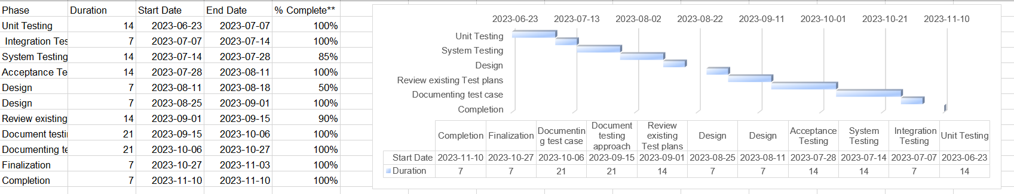

# PLANNING RISKS AND CONTINGENCIES

In this section, we identify potential challenges that may occur during testing. We assess the likelihood and impact of these challenges and create plans to overcome them. This information is presented in a table for easy reference. The goal is to be well-prepared for any uncertainties, ensuring a smooth testing process and successful project outcome.

Table 13: Risk Mitigation Plan for testing

|  |  |  |  |  |
| --- | --- | --- | --- | --- |
| **S/N** | **Risk Description** | **Probability** | **Impact** | **Mitigation Plan** |
| 1 | Lack of Team Collaboration | 20% | Delay in a Task Completion | Establish regular virtual and use collaborative tools |
| 2 | Internet  Connectivity Issues | 15% | Disrupted Communication | Have backup internet solutions and use offline collaboration |
| 3 | Inconsistent Work Hours among Team Members | 10% | Project Delays | Define and communicate clear working hours and schedules |
| 4 | Miscommunication on Task  Requirements | 12% | Inaccurate Testing | Use project management tools for clear task descriptions |
| 5 | Team Member Unavailability | 18% | Reduced Test Coverage | Cross-train members and have backup responsibilities |
| 6 | Changes in Project Scope | 14% | Expanded Testing Scope | Establish a change management process and regular reviews |
| 7 | Technical Issues with Remote Collaboration Tools | 15% | Communication Delays | Regularly update and test collaboration tools for efficiency |
| 8 | Unavailability of Test Environment | 10% | Delay in Testing | Have a backup test environment and coordinate with IT |

# APROVALS

* 1. [MD. Samir Khan], Lead Product Manager.
  2. [Ms. Sayra Banu], QA Manager.
  3. [Solimullah Kha], User Experience Designer.
  4. [Shah Aziz], Development Team.
  5. [Abrar Faisal], Technical Writer.
  6. [Tansen Zaman], Business Analyst.